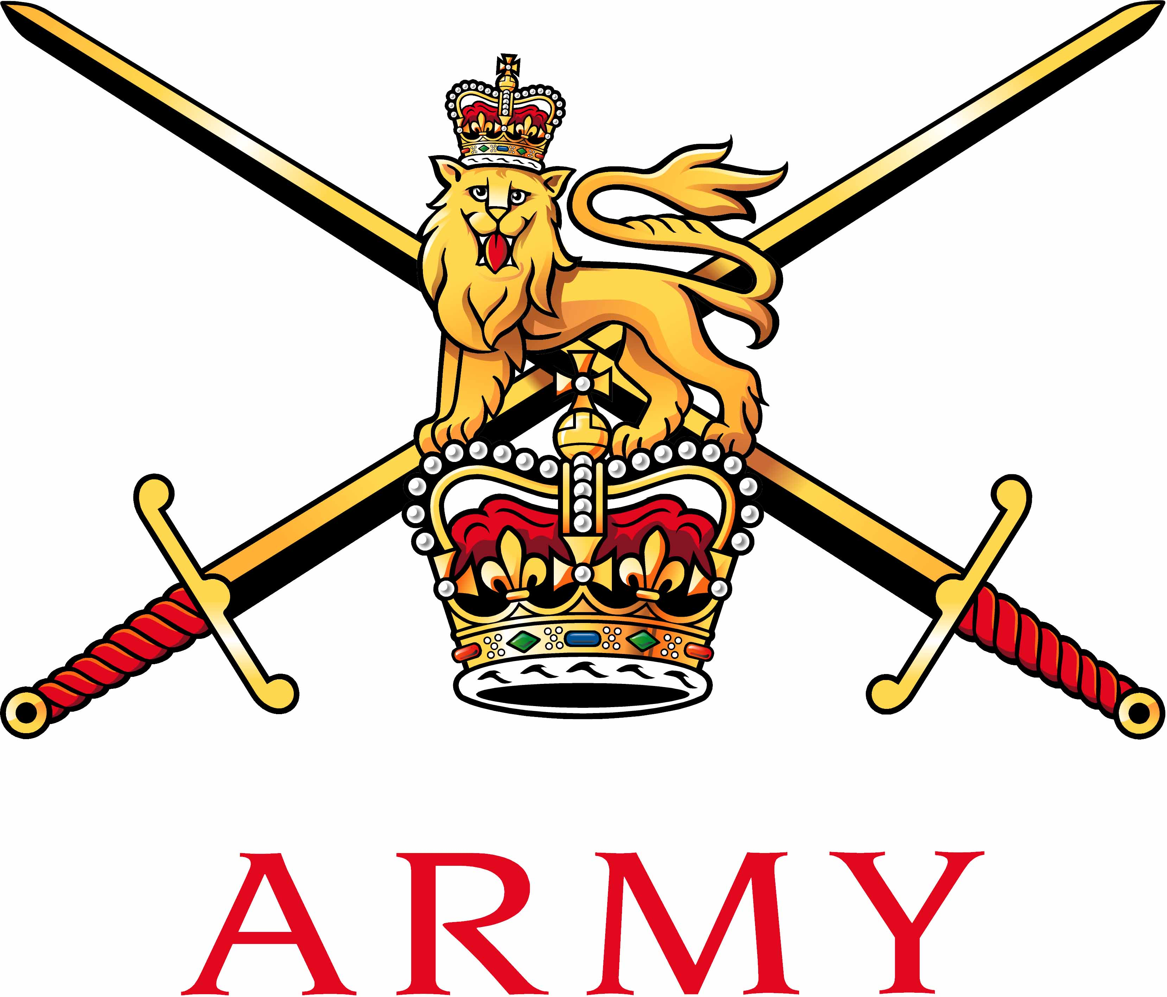 | Secretary Army Boxing Association  Army Sport Control Board  MacKenzie Building, Fox Lines,  ALDERSHOT, Hampshire GU11 2LB  Email: aba@ascb.uk.com  Website: www.britisharmyboxing.com |  | 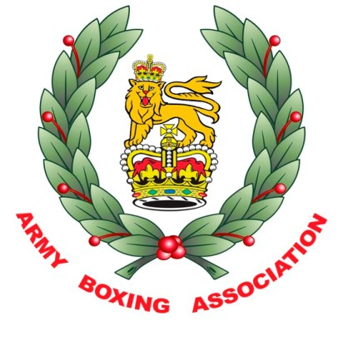
Telephone: 01252 787089 Fax: 01252 787094
Military: 94222 7089 Military: 94222 7094
See Distribution |  | Reference: 20200813_ARMYBA_AGM_SEC_U  Date: 13th August 2020

RECORD OF DECISIONS FROM THE ARMY BA AGM WHICH WAS HELD VIA ZOOM ON 13th AUGUST 2020

Present | Brig C Barry OBE | Chairman | CB
 | Col C Phillips CBE | Vice Chairman (Operations) | CP
 | Maj A Buff | Chairman Midlands | AB
 | Maj L Cugudda | Comms and Media | LC
 | Maj N Homer MBE | Team Manager | NH
 | Capt S Milligan | Assistant Team Manager | SM
 | Capt L Harkin | Chairman South | LH
 | Capt Kirkham MBE | Chairman North | KB
 | Sgt J Allen | Team Coach | JA
 | Mr Ben Stewart | Team Technical Lead | BS
 | Mr Nathan Pearce | Secretary | NP
 | Mrs Faye Walters | Army Boxing Admin Officer | FW
Apologies | Maj C Roberts | Officials Development & Appointments Officer | CR
 | Capt C Coward | Dev Team Manager | CC
 | Dr Ross Walker | Senior Medical Officer | RW
 | Lt Col D Cugudda | Vice Chairman (Strategy) | DC
Introduction and welcome  - The Chairman welcomed the members.  - The Chairman thanked NP for Army Boxing being in a good place despite the abrupt end to the season due to COVID 19.  Item 1– Previous minutes and matters arising  - The previous minutes were accepted as a true record of the meeting.  Item 2 – Statement of account / Sponsorship / Forecast of Expenditure  - Statement of Accounts.  The account was reviewed after the ASCB audit to clarify the significant difference in income and expenditure, the difference was largely due to England Boxing not invoicing previously for courses run by Army Boxing, the cancellation of the SBS show and Sponsorship money being held or not yet paid.  - Sponsorship.  NP explained that sponsorship was unstable this year due to the uncertainty of COVID 19 and the limited amount of boxing meaning that the Army BA was unlikely to fulfil it’s sponsorship obligations;  - Techmodal have requested a pause on their contract renewal but may look at renewing in the future. They have also only committed to paying half of this year’s Sponsorship to the sum of £5k. With Techmodal not renewing this means that the Army Team do not have a shirt sponsor.  - Leonardo have still not signed a contract to sponsor Army Boxing, NP is still awaiting a response from Mongoose on the Situation. Therefore no money has been paid to the Association, this leaves a deficit of £7.5k.  - CB noted he sees sponsorship risk but does not feel it is an issue at the moment.  NP explained the DACSB may match any losses as required due to the current COVID situation.  - Forecast of expenditure 2020/2021  NP explained that it was difficult to forecast expenditure this year due to the current climate, however it is unlikely that expenditure will be significant. Income would also be limited and the Association may only get 50% or less in registration payments. However Army BA should forecast for 2021/2022 based on a normal year.  CB requested another meeting in September with NP and NH to review the forecast before ASCB finance bids are due to be submitted.  Item 3 – Reports  All reports were submitted prior to the conference call for the committee to review. All regional Secs. Commented there were no issues to be raised.  NP made the committee aware that Sgt Duffin had now left the Army and has handed the LONDIST district appointment to an inexperienced RAPTC member. NP was resolving the issue to appoint a more experienced Major Panel Boxing Association member.  KK explained that 1SCOTS in NI would like to set up a new Boxing gym for serving personnel, dependants and some civilians inside of the wire. NP and KK noted that although it would be good for community engagement it does carry a security risk. NP is currently working with England Boxing to try to resolve any issues.  CB remarked that the 1SCOTS Boxing gym is a brilliant initiative however it does come at risk and the CO 1SCOTS should work with all stakeholders before acting.  NP reported that England Boxing have taken much of the Officials course syllabus in order to nationalise all course material, this is a great endorsement from England Boxing proving that the UKAF officials cohort are well respected and regarded as some of the best on the circuit. It was noted that SSgt Emma Smith (RLC) had been fast tracked to a grade A Referee after being mentored by Maj Chris Roberts. CB remarked that SSgt Smith should be made example of, CB suggested an article in Soldier magazine, Army Sports Awards and Women in Defence Awards.  Maj Roberts is hoping to hand over the UKAF Officials appointments to Flt Lt Ian Ireland (RAF) however he will continue to appoint the Army Major Panel Officials with SSgt Smith as his 2IC.  Item 4 – Strategy  NP explained that DC was currently on Operations and therefore NP and NH had proceeded with the Strategy for Army Boxing. The programme has so far been successful with the Army being currently represented by 4 Boxers at International level, Gnr’s Artingstall and Willetts - GB, LCpl Reid - Scotland and LCpl Marvin – Philippines.  BS presented an Analysis of pathway and competition market to the committee and recommended that Army BA continues to target boxers internally as well as boxers from the various home nation pathways (England, Scotland, Wales and Ireland).  CB requested BS work with the home nation programmes to establish a pool of 18 year old boxers for possible recruitment purposes.  Item 5 – Appointments / TORS / Working Groups / Ambassadors  - Appointments  A discussion was had to decide if the appointment for Recruitment/Comms/Sponsorship should be spilt into 3 separate appointments. It was decided that it should not and LC should continue in the role but a 2IC should be sourced to help with the workload.  - TORS  NP had distributed the TORS at an earlier date for the committee to review, all members agreed these to be accurate.  - Ambassadors  A discussion was had to the relevance of appointing Army Boxing Ambassadors. The role would involve Ex team members to go to home nations training camps and speak to potential recruits about a career in the Army whilst also being able to box.  Suggested Ambassadors would be:  Cpl Alanna Nihell – NI  Cpl Kyle Morrison and Cpl Ashley Williams – Wales  Cpl Sean Dick and LCpl Megan Reid – Scotland  NP to identify ambassadors for the 4 home nations and report back to the subcommittee (NP, LC,BS,CP,CB) to be incorporated into the 5 year plan.  Item 6 – Handbook / Registrations / My Next Match  - Handbook  NP reported that the new 20/21 UKAFBA handbook was complete and ready for distribution.  - Registrations  FW explained that we had been working with 4 Global and England Boxing to produce a new Service Only online registration process on the Vault. The new development will enable Army BA to be GDPR compliant, less paperwork to be stored in the office, more efficient and will enable us to assure the sport more effectively. There would also be no change to the cost for our members.  The change will take effect from 1st September 2020.  - My Next Match  NP explained that England Boxing were introducing a medical database as an assurance mechanism. All England Boxers would have their medical data input onto My Next Match by the Doctor at the point of initial medical, pre bout and post bout medicals, this will be phased in over the next season. The UKAF already do this via DMCP so it brings in some issues for the UKAF Association, namely duplication of medical records and MO’s also having to enter the details onto My Next Match. NP has been working with England Boxing to resolve the matter and will continue to do so to find a satisfactory solution for all parties.  Item 7 – Resumption of Boxing  NP advised the committee that he had confirmed with the Director ASCB that Boxing would not be allowed to resume in the current climate until Government restrictions are lifted. This means the Army boxing team are unlikely to be brought back to Aldershot until at least January 2021.  England Boxing have cancelled all championships for the duration of 2020.  CB suggested that a line should be drawn under the current season and a discussion with the RN and RAF should be had to regarding a date change of the Inter Services until Summer 2021 in order to give Boxers sufficient time to prepare.  NP is to consult with the other 2 services on the proposal.  It was decided that a meeting should take place in November 2020 to discuss how to proceed with Boxing in 2021.  It was decided that due to the uncertainty of Boxing in the current climate no viable decisions could be made with reference to the following events and activities.  - Return to training  - Return to club shows  - Championship preparations  - Championships  - Haringey  Item 8 – Army Boxing Championships  No discussion was possible on this subject as no date for the resumption of boxing is forecast or what restrictions or conditions would be imposed.  Item 9 – Officials and Coaches courses  Until current government restrictions are lifted no dates or actions with reference to this agenda item can be forecast.  Item 10 – UKAF Boxing Association AGM / Inter Services Boxing Championships / UKAF Boxing Association Update  CB agreed that the UKAF AGM should not take place in September but moved to November to allow for greater understanding of any possible timetable for competitive boxing in the hope that the future may be clearer at this time.  The IS Championships and any UKAF Boxing update would be added as agenda items for this meeting.  Item 11 – AOB  - Defibrillators  NP advised the committee that England Boxing will be implementing the instalment of Defibs in all affiliated clubs starting in the 2021/2022 season. CB commented that this could be an issue for the Army/Units namely funding of the equipment.  It was decided that NP should establish whether units need Defibrillators in the first instance.  - Action Plan  KK remarked that the Army Boxing Association action plan key performance indicators should also include the Officials cohort.  - Technical Lead Coach  NP advised the committee that BS contract expires in March 2021, BS has decided he will be leaving the role at that point.  Item 12 – Date of the next meeting  Nov 2020 |  |  | CB, NP, NH  BS  LC  NP  NP  NP  NP/CB/NH  NP  NP

N L Pearce
For Chairman

Distribution:
ARMY BA General Committee

