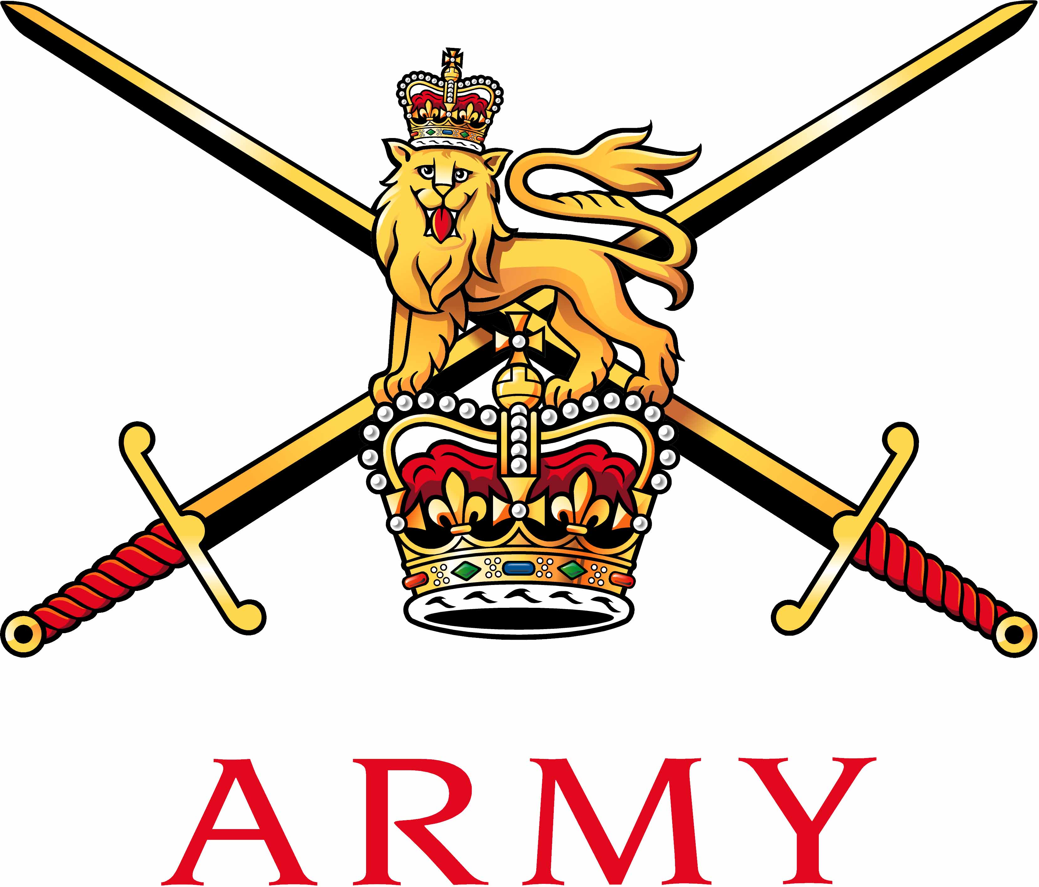 | Secretary Army Boxing Association  Army Sport Control Board  MacKenzie Building, Fox Lines,  ALDERSHOT, Hampshire GU11 2LB  Email: aba@ascb.uk.com  Website: www.britisharmyboxing.com |  | 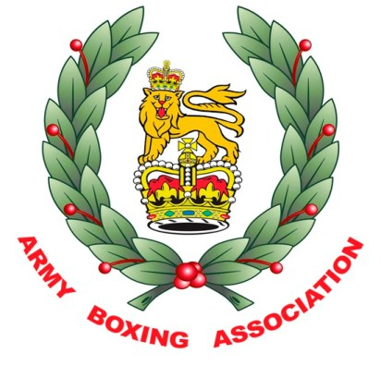
Telephone: 01252 787089 Fax: 01252 787094
Military: 94222 7089 Military: 94222 7094
See Distribution |  | Reference: 20170919_ARMYBA_AGM_SEC_U  Date: 19 Sept 2017

RECORD OF DECISIONS FROM THE ARMY BA AGM HELD AT ARMY SCHOOL OF PHYSICAL TRAINING ALDERSHOT 19 SEPTEMBER 2017

Present | Brig S Hamilton OBE | Chairman | SH
 | Col C Barry OBE |  | CB
 | Mr N Pearce | Secretary | NP
 | Maj Cugudda | Team Manager | DC
 | Capt L Harkin | Chairman South | LH
 | Capt A Buff | Chairman Midlands | AB
 | WO2 Mann | Secretary North | SM
 | SSgt Harrison | Secretary South | MH
 | SSgt Browring | Team Coach | JB
Apologies | Capt Kirkham-Brown | Chairman North | KB
 | Capt Roberts | Officials Appointments Officer | CR
 | Dr Walker | Senior Medical Officer | RW
Item 1 – Introduction and welcome  - Chairman welcomed the members.  - The Chairman commented on the success of the both the Elite and Development Boxing squads and thanked everyone involved in helping to deliver this success.  Item 2 – Previous minutes and matters arising  - The previous minutes were accepted as a true record of the meeting.  Item 3 – Statement of accounts  - Audit. The Army BA is audited as part of the ASCB Central Bank.  - Accounts. The Army BA account 1514 and full audited account was provided to the committee.  - Forecast of expenditure. A forecast for Army BA is required to ensure that funds are available to support the Army Boxing Strategy.  - Sponsorship. A letter of thanks be sent to each sponsor to thank them for their financial support to Army BA.  - Techmodal continue as the Army Team shirt sponsor at £10000.  - Babcock continue to sponsor the Army Champs and Army Individuals at £13000  - Selex ES Team Sponsors - £7500  - DB Santasalo Team Sponsors - £3000  - Atkins - £3000  - FBT Boxing kit sponsorship – Clothing and strips.  Item 4 – Appointments.  - The Army BA committee is as follows;  - Chairman – Brig Simon Hamilton OBE  - Vice Chairman – Col Chris Barrie OBE  - Chairman North – Capt Kirkham-Brown  - Chairman Midlands – Captain Buff  - Chairman South – Capt Harkin  - Secretary North – WO2 Mann  - Secretary Midlands – SSgt Spearitt  - Secretary South – SSgt Harrison  - Officials Appointments – Capt Roberts  - Team Manager – Maj Cugudda  - Asst Team Manager – Capt Milligan  - Senior Medical Officer – Dr Walker  - Operations Manager – N Pearce  Item 5 – Fixtures.  - A detailed list of fixtures is attached (these include dates for the Inter Services, major events and who is to represent the Army BA) as follows;  - IS Dev Champs – 26 & 28 Sept – Brize Norton -VC  - IS Elite Champs - 20 & 22 March – Aldershot – President, Chairman, VC  - Army Team Final Aldershot – 12 May (dates of rounds are provided on forecast) - President, VC.  - Army Individual Champs June 3 – 7 June 2018 - President, Chairman, VC  Item 6 – Reports.  - NP summed up the season and provided a report of the previous season;  - Army BA  - Army Boxing registered in the 2016 season  - Boxers - 2056  - Officials - 229  - Coaches – Qualified – 417 Registered - 437  - Teams Affiliated – 67  - Events licensed – 64  - Results  Inter Service Champions 2017  Army Inter Unit Development A Team Championships –  Winners – 13 Air Support Regiment RLC  Finalists – 3rd Battalion the Parachute Regiment  The Army Boxing Association had an extremely successful season;  Individual honours  Cpl Wroe – Army and UKAF Sportswoman of the Year 2016  LCpl Ngwenya GB Elite Title – Winner  England Elite Title – Finalist  Southern Area Belt – Winner  Spr Jones GB Elite Title – Winner  England Elite Title – Winner  GB Potential Podium Squad.  LCpl Williams GB Elite Title – Finalist  Wales Elite Title – Winner  England Elite Title – Bronze  Cpl Wroe – England Elite Title – Winner  GB Elite Title – Finalist  England Title Belt – Holder  LCpl Morrison GB Elite Title – Bronze  Wales Elite Title - Winner  Gnr Fillingham – England Title Belt – Winner  LCpl Khan – England Title Belt – Winner  LCpl Nihell – England Title Belt – Winner  Haringey Box Cup – Winner  Cpl Burton - Scotland Elite Title - Finalist  LCpl Reid - Scotland Elite Title – W/O win  Fus Eng - Scotland Elite Title - Bronze  Cpl A Nihell – Haringey Box Cup - Winner  International appearances  Cpl Burton Scotland  Cpl Wroe England  LCpl Marvin Phillipines  LCpl Morrison Wales  LCpl Nihell England  LCpl Reid Scotland  LCpl Williams Wales  Fus Eng Scotland  Gnr Fillingham England  Spr Jones GB  Team Honours  Inter Service Champions 2017  Haringey Box Cup Runners Up 2017  - Reports from each region and from the Team and Officials were also provided and gave a comprehensive look back at a very successful season in all areas for Army Boxing.  Item 7 – Coaching Team.  - NP gave an update on the progress to recruit an International coach for the Army Boxing Team and explained that this would be funded from the Army Elite Athlete Support Programme. LH expressed concern that this appointment would be held by a civilian and felt that the role of Army Coach should be held by a serving soldier. NP explained that a SNCO would work very closely with the appointed coach to ensure that any military policies, protocols and relationships were upheld and that this was an excellent opportunity for the Army Boxing Team.  - NP expressed a concern that SSgt Ingleby would not be released by his unit to continue in his role on the Army Coaching staff. CB will look to engage to provide a solution if possible to this.  Item 8 – Medical Matters.  - CB expressed real concern that the loss of consent from Military Drs in support of the sport was a major threat to boxing and where possible we should work with the medical chain.  Item 9 – External Influences.  - NP explained that AIBA our international governing body was in a state of discord with a vote of no confidence tabled against the current President with an accusation of financial misconduct. The International Olympic Committee is very uncomfortable with the situation as reputational risk to their organisation. The current situation remains unstable and could influence the decision to allow boxing to take place at the Olympic Games in Tokyo 2020.  Item 10 - Army Inter Unit Championships.  - The date for the final of the Championships is 12 May 2018, dates for semi-finals and  rounds of the tournament are included on the FOE.  - The competition will remain a straight draw.  - The format for the competition was discussed at length and eventually it was decided that the championship would be contest over 8 weight with all bouts would be boxed over 3 x 2 minute rounds, The weights for the competition and the order they will be boxed is as follows;  8 boxers as 56, 60, 64, 75, 81, 86, 91 and 69kg  - A match between units will be won if;  - Either units wins 5 or more bouts  - If both units win 4 bouts the winner of the last bout (69kg) will win the match.  - All boxers are to have boxed at least twice but may not have boxed 11 times.  Army Inter Corps and Individual Championships.  - The format for the Army Individual Championships will remain unchanged for 2018 less any rule changes imposed by AIBA or England Boxing.  - The dates for the Championships would be 3 – 7 June 2018.  Inter Service Boxing Championships.  - The date and location for the Inter Services Boxing Championships would be 20 & 22 March in Aldershot.  Item 11 – Recruiting  - Major Lydia Cugudda (Army Recruiting) has worked with the Team Manager and coaching staff of the Army Boxing Team on an initiative to provide recruiting support whilst at shows and championships. This initiative is to be briefed to Director ASCB and the Army Recruiting Chain of Command for endorsement.  Item 12 – AOB.  - Risk to Life Register – The Chairman requested that all Commanding Officers add any boxers from their units that were in training be added to their Risk to Life Register. NP agreed to include this in the Official Handbook and to brief the request at the annual conference in Sept.  - Olympic Boxing Weights – A debate between the International Olympic Committee and AIBA has developed about weights for the 2020 Olympic Games. The IOC want AIBA to adjust its competition weights to move towards parity of gender in the participants – currently boxing has 10 male competition weights and 3 female. AIBA have agreed to increase the competitive weights for females from 3 to 5 but have resisted the request to reduce male weights from 10 down to 8. It is understood that the female weights will be;  51, 57, 60, 69 and 75kg  With no agreement between the parties there is no decision on the male weight categories.  - Presentations to Officials – JB made a plea to units organising boxing events that they need not make presentations to visiting officials. This was unanimously agreed but could only be advised. NP agreed to mention this to Boxing Officers at the Annual Conference in Sept.  - Medical Cover and Annual Medicals for boxers – Via email KB raised the ongoing issue of the limited medical support in the form of Ringside Doctors and Annual Medicals for Boxers especially in the North of England. It was agreed that NP would brief Director Army Sport Control Board.  29. Meeting Frequency – The Chairman expressed a wish for more regular meetings to allow him to keep abreast of progress and to be able to intervene early where appropriate.  Item 12 – Date of the next meeting  30. January 2018 |  |  | NP  NP  CB  NP  NP  NP

N L Pearce
For Chairman
CSBA Sec

Distribution:

All ARMY BA members

