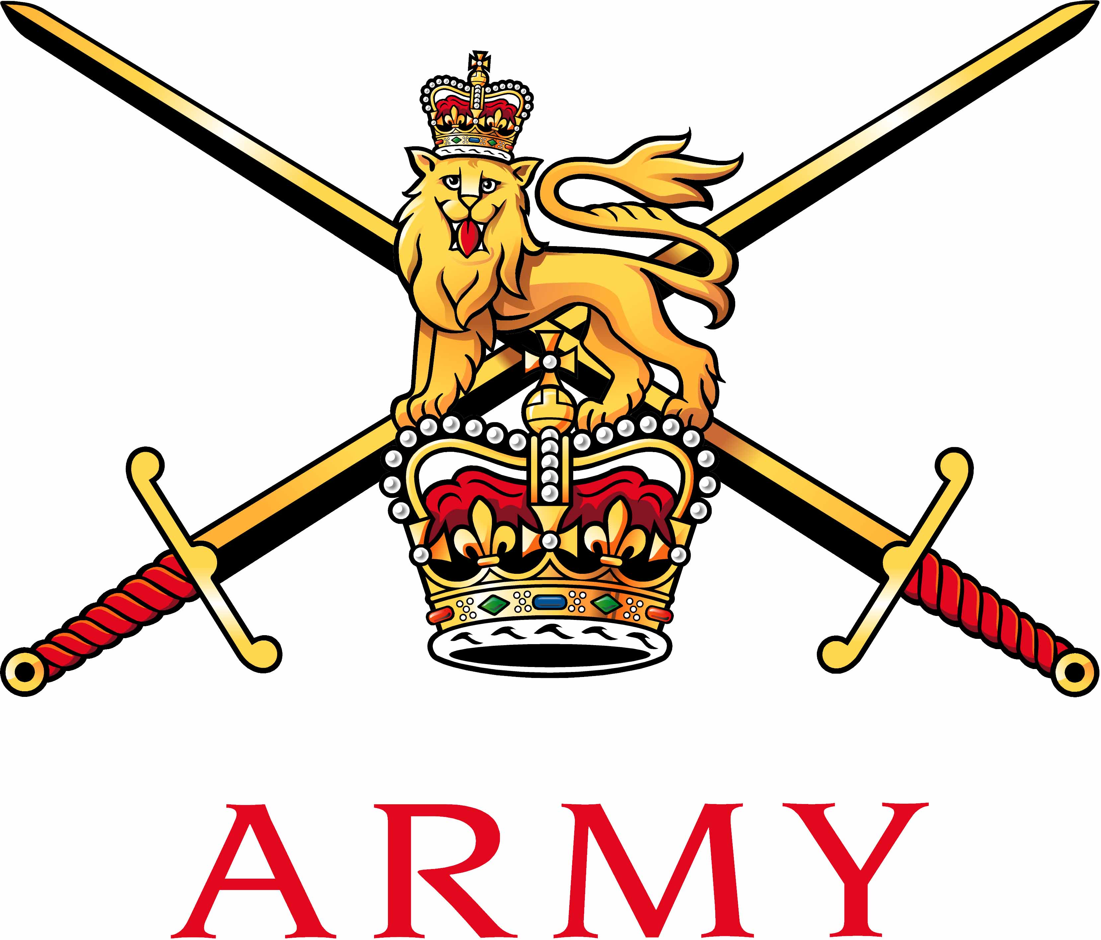 | Secretary Army Boxing Association  Army Sport Control Board  MacKenzie Building, Fox Lines,  ALDERSHOT, Hampshire GU11 2LB  Email: aba@ascb.uk.com  Website: www.britisharmyboxing.com |  | 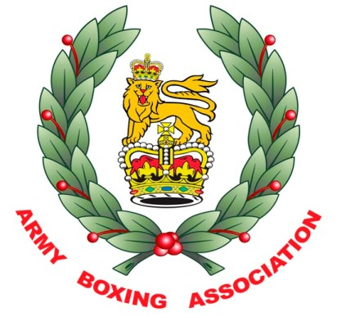
Telephone: 01252 787089 Fax: 01252 787094
Military: 94222 7089 Military: 94222 7094
See Distribution |  | Reference: 20190905_ARMYBA_AGM_SEC_U  Date: 05 Sept 2019

RECORD OF DECISIONS FROM THE ARMY BA AGM HELD AT ARMY SCHOOL OF PHYSICAL TRAINING ALDERSHOT 28th AUGUST 2019

Present | Brig C Barry OBE | Chairman | CB
 | Lt Col D Cugudda | Team Manager | DC
 | Maj T Buff | Chairman South | TB
 | Maj L Cugudda | Comms and Media | LC
 | Maj N Homer MBE | Dev Team Manager | NH
 | Maj S Milligan | Assistant Team Manager | SM
 | Maj C Roberts | Officials Appointments and Development | CR
 | Capt L Harkin | Chairman South | LH
 | Capt Kirkham MBE | Chairman North | KB
 | WO1 S Mann | Secretary North | SM
 | Sgt J Allen | Team Coach | JA
 | Sgt J Battle | Sec Midlands | JB
 | Mr Ben Stewart | Team Technical Lead | BS
 | Mr N Pearce | Secretary | NP
 | Mrs Faye Walters | Army Boxing Admin Officer | FW
Apologies | Col C Phillips | Vice Chairman | CP
 | Capt C Coward | Dev Team Manager | CC
 | Dr Walker | Senior Medical Officer | RW
 | WO2 D McGregor | Sec North Des | DM
 | WO2 L Richardson | Dev Team Coach | LR
 | SSgt S Turner | Sec South | ST
Item 1 – Introduction and welcome

- The Chairman welcomed the members.

- The Chairman commented on the success of the both the Elite and Development Boxing squads and thanked everyone involved in helping to deliver this success.

- The Chairman highlighted some threats and opportunities for the committee to be aware of;

Threats
- Medical issues – a number of accidents/incidents have occurred in the season that could have either been avoided or better managed by units and coaches and we must look to address this.
- AIBA – the governance and political wrangling with the International Olympic Committee has continued to create issues within the sport.

Opportunity

- 2020 Olympic Games is on the horizon as is the European Qualifier in London.

Personal Observation – Boxing is a well run sport and although there are continual challenges to overcome in a shrinking and committed Army he is confident that the sport is in good hands.

Item 2 – Previous minutes and matters arising

- The previous minutes were accepted as a true record of the meeting.

Item 3 – Statement of accounts

- Audit. The Army BA is audited as part of the ASCB Central Bank.

- Accounts. The Army BA account 1514 and full audited account was provided to the committee, NP explained that the statement of account is now for the financial year and not a seasonal report.

- Sponsorship.

The current income from sponsorship is as follows.

- Techmodal continue as the Army Team shirt sponsor at £10000.
- Babcock continue to sponsor the Army Champs and Army Individuals at £13000
- Selex ES Team Sponsors - £7500
- FBT – Tracksuits, competition strips, polo shirts and t-shirts.

Due to the separation from Team Army, the following loss of support will occur;

- DB Santasalo Team Sponsors - £3000
- Atkins - £3000
- Team Army Foundation grant - £3000

NP explained the DACSB has pledged to match any losses as required.

DC requested information on what is required from Army Boxing as a commitment to FBT and NP explained that we were required to wear the brand for competition and for all formal media opportunities.

- Further Sponsorship opportunities – Unit Level and Corps Level Boxing events are clear opportunities for sponsorship and NP explained that he will liaise with Mongoose to assess the options and how to take this forward.

- Sports Equipment Public Fund – The Army Boxing Team Coaches have provided a
breakdown of the requirements for the team to the cost of £9816 and this will be included in the Army Boxing Annual Grant bid.

- Forecast of expenditure 2019/2020 – NP detailed a number of items additional to routine expenditure to improve the ability of the Army BA to host events and to improve the service to the Army BA and the look of the Combat Sports Centre, details of each of the items with costs was provided to the committee as;

- Honours Boards - £600 x 4 = £2400 (to capture historical achievements)
- Large Screen TV and Stand - £1500 (for courses, training and awards dinner)
- Flag - £600 (to permit Army BA to loan out a flag for unit competitions for branding)
- Wall Graphics -£4500 (to promote Core Values in the gym and to improve entrance.
- Trophy Cabinets - £1200
- Chairs for VIP Seating - £3350 (Chairs with branded seat covers for events as hiring is not cost effect or appropriate, loan from units is just not feasible, Aspire chairs are not appropriate for the VIP Seating).

All of the above was agreed with the caveat that any Wall Graphics must be selected to ensure that where possible it will not need to be replaced due to sponsorship commitments, it reflects the longevity of Army BA, includes boxers, coaches and officials and is generic.

- 4 Global Registrations Database – NP was tasked by DASCB to try to remove some of the paper administration of the Army BA registration process. The best option was to add a page to the current England Boxing database that will allow boxers, coaches and officials to initiate registration online for Service Only Boxing in the same way as those boxing in a civilian environment. The database and process will be more efficient as well as being GDPR compliant. The project will be funded by DASCB the total cost of this will be a maximum of £12k.

Remaining expenditure is expected to be in line with previous annual costs meaning income and expenditure are approximately the same.

Item 4 – Appointments.

- The Army BA new appointments;

Chairman – Brig C Barry OBE
Vice Chair Operations - Col Claire Phillips
Vice Chair Strategy - Lt Col Dominic Cugudda
Senior Team Manager – Maj N Homer MBE
Senior Team Assistant Manager – Maj S Milligan
Chairman London District – Maj T Buff
Development Team Manager – Capt C Coward
Secretary North - WO2 Donald McGregor
Secretary Midlands – Sgt Battle

Item 5 – Fixtures and Invitations

- A detailed list of fixtures is attached (these include dates for the Inter Services, major events and who is to represent the Army BA) as follows;

- IS Dev Champs – 19 Sept – Brize Norton – DC, NH & CC
- IS Elite Champs - 19 or 26 March – Aldershot – All
- Army Team Final Aldershot – 14 May (dates of rounds are provided on forecast) - President, VC.
- Army Individual Champs June 7 – 11 June 2020 - President, Chairman, VC
- Army Boxing Awards Dinner 25 June - All

Item 6 – Reports.

- NP summed up the season and provided a report of the previous season;

Army BA

  - Army Boxing registered in the 2017/18 season

    - Boxers - 1563
    - Officials - 183
    - Coaches – Qualified – 344 Registered - 412
    - Teams Affiliated – 63
    - Events licensed – 55

- NP expressed concern that it has been another season that has seen approximately a 10% drop in registrations.

Results

Inter Service Champions 2019

Army Inter Unit Development A Team Championships –

Winners – 3rd Battalion the Parachute Regiment
Finalists – 13 Air Assault Support Regiment RLC

The Army Boxing Association had an extremely successful season;

Individual honours

Female –

51kg Gnr Willetts – GB Elite Title – Silver
England Elite Title – Winner

51kg Gnr MacAuley - England Development A – Winner

54kg Spr Jones - World Championship England Representative

57kg Gnr Artingstall - 2 X International Box Cup Winner
GB Representative
GB Podium Squad

64kg LCpl Reid - World Championship Scotland Representative
GB Elite Title – Finalist
Scotland Elite Title – Winner

64kg LCpl L Lee - England Development A – Winner

69kg Sgt C Roberts - England Development A – Finalist

Male -

52kg Spr M Smith - England Development A – Finalist

56kg Cpl S Khan - Haringey Box Cup Elite Winner

56kg Cpl K Morrison - Wales Elite Title – Winner

56kg LCpl C Mahoney - England Development A – Finalist

81kg LCpl J Marvin - Asia Champs – Silver

81kg LCpl Brown - England Elite Title – Bronze
England Development B - Winner

91kg LCpl Ngwenya - GB Elite Title – Winner
England Elite Title – Winner
International appearances

LCpl Marvin Phillipines
LCpl Morrison Wales
LCpl Ngwenya England
LCpl Reid Scotland
LCpl Willetts England
Gnr Artingstall GB
Spr Jones GB

Team Honours

Inter Service Champions 2019

Officials

Major T Buff – Chemistry Cup - Germany
Major C Roberts – European Youth Games – Italy, EU Championships – Spain, European Schools Championships – Georgia, GB Elite Champs, GB Schools Champs and England v Scotland.
Captain K Kirkham MBE – GeeBee Tournament – Helsinki
WO1 SMI S Mann - GB Elite Champs, GB Schools Champs and England v Scotland.

- Reports from each region and from the Team and Officials were also provided and gave a comprehensive look back at a very successful season in all areas for Army Boxing.

Item 7 – Strategy

- Following a recent strategy meeting, a number of actions needed to be addressed to aid the Army Boxing Team to recruit and DC as the newly appointed Vice Chair responsible for Strategy agreed to act on the following issues;

- Strategy to be updated to reflect 2020 Olympic Games and 2022 CWG
- Develop relations with England Boxing
- Liaise with Regional Command Community Engagement cell with a view to greater exposure at Major domestic competitions.
- To help manage the mechanism to host training camps for Scotland Wales and England
- Discuss with Army Recruiting how the boxers can get actively involved in recruiting.

Item 8 – England Boxing & AIBA Update

- NP gave an update on the current situation between AIBA and the IOC; the IOC have given a vote of No Confidence in AIBA as an organisation. The IOC will now appoint an external organisation to run the boxing at the Tokyo Olympics. This organisation will release details in the near future about how boxers will qualify for the tournament and when.

- EB update – There will be very few domestic rule changes that affect soldiers, however any significant changes are outlined below and will be briefed at the Annual Conference and added to the UKAFBA Official Handbook as follows;

- Domestic weights will not change.
- Concussion protocols for boxers for a safe return to training and work / school have been cleared by the England Boxing Medical Commission. There is scope for some confusion in that the protocols are under and over 19 years of age where as the senior boxing category is on the Year of Birth a boxer turns 19. NP suggested we must brief all of the Army Boxing Supervisors accordingly. NP will also ensure that the Army BA Drs be aware of this too.

- Dress regulations have changed for boxers as follows;
Male – No longer required to be clean shaven. However boxers representing the Army must still adhere to the regulations for beards and moustaches for soldiers.
Female – A Hajib and full body covering may be worn if a boxer has a religious or cultural reason but this must be communicated to the Supervisor at the weigh in.

Item 9 – Medical Matters

- NP briefed the committee that he was near to completing a UKAF Boxing Association Handbook to replace the Army Boxing Handbook. The new publication will reflect the protocols and policies of all 3 Services and should ensure that all 3 Single Service Boxing Associations will follow the same rules and procedures.

- Sqn Ldr Tom Bennett Britton has taken over from Ross Walker as the UKAF BA Senior Medical Officer and is currently working on an update to JSP 950 Leaflet 2-1-1 The Medical Management of Service Boxing.

- NP briefed the committee about 3 significant medical incidents from boxing activities in the last year that showed a trend that coaches were unaware of their responsibilities for managing soldiers reporting to training with headaches and incident reporting.
After significant discussion a number of points and ideas were tabled as follows;
- NP Boxing Officers must attend the conference or be briefed by their Regional Chairman or the Army Boxing Sec if they did not attend the conference.
- CR suggested we investigate an online boxing officers course.
- DC can we put the conference presentations online for them to view.

- It was agreed that NP would address the issue in the forthcoming issue of the UKAF BA Official Handbook as follows;
- A Unit Emergency Action Plan is to be added to the Boxing Officer Section of the UKAFBA Handbook.
- The Unit Affiliation application will require the Boxing Officer to sign to say he/she has briefed the unit coaches and that the understand the Unit Emergency Action Plan and that he/she has read and understood their duties as the Unit Boxing Officer.
- A Unit Incident reporting flowchart is to be added to the UKAFBA Handbook in the Boxing Officer Section to ensure that all Boxing Officers are aware of the appropriate reporting actions that must be taken on the occasion of any incident.
- All of the above will be briefed at the Annual Conference.
- Any Unit affiliation application where the Unit Boxing Officer did not attend the Annual Conference would be withheld until the Boxing Officer had been briefed by either the Army BA Sec or the Regional Chairman.
- NP is to speak to ASCB Assurance Officer and COS about how to develop an E-Learning Boxing Officer Course.

Item 10 - Army Inter Unit Championships.

- The date for the final of the Championships is 14 May 2020, dates for semi-finals and
rounds of the tournament are included on the FOE.

- The competition will remain a straight draw.

- The format for the competition was discussed at length and eventually it was decided that the championship would be contest over 8 weight with all bouts would be boxed over 3 x 2 minute rounds, The weights for the competition and the order they will be boxed is as follows;
9 boxers as 56, 60, 64, 69, 75, 81, 86, 91 and 91+kg

- A match between units will be won if;

- Either units wins 5 or more bouts

- All boxers are to have boxed at least twice but may not have boxed 11 times.

Army Inter Corps and Individual Championships.

- The format for the Army Individual Championships will remain unchanged for 2020 less any rule changes imposed by AIBA or England Boxing.

- The dates for the Championships would be 7 – 11 June 2020.

Inter Service Boxing Championships.

- The date and location for the Inter Services Boxing Championships would be 19 or 26 March in Aldershot.

Additional Competitions.

- NP suggested that the Army BA could add some additional fixtures to the calendar in a bid to identify talent for the team.

- Infantry Championships – 5 bouts and under as a week long tournament in Oct.
- Female Box Cup – Class A, B and Elite in Feb.

Both competitions need further investigation for inclusion in the programme. NP is to report back to the committee.

Item 12 – AOB.

A – Media and Communications – LC stated the Newsletter had been well received by all but there was still much work to do including setting up a new Facebook page for the team to publish information on activities.

B – Recruiting – LC advised the committee that she had made good links with Capita in London through Matt Turner and we should look to exploit this. KK asked if we should utilise the experience of the coaches and officials in support of the recruiting options.

C – Release of Boxers – NP explained that the coaches were not aware of which boxers would return after the Summer break until the boxers were on the Summer break which made preparation for the season difficult. It was agreed that CP and NH would contact Commanding Officers in Mar / Apr of each year.

Item 13 – Date of the next meeting

33. July 2020

N L Pearce
For Chairman

Distribution:
All ARMY BA members

