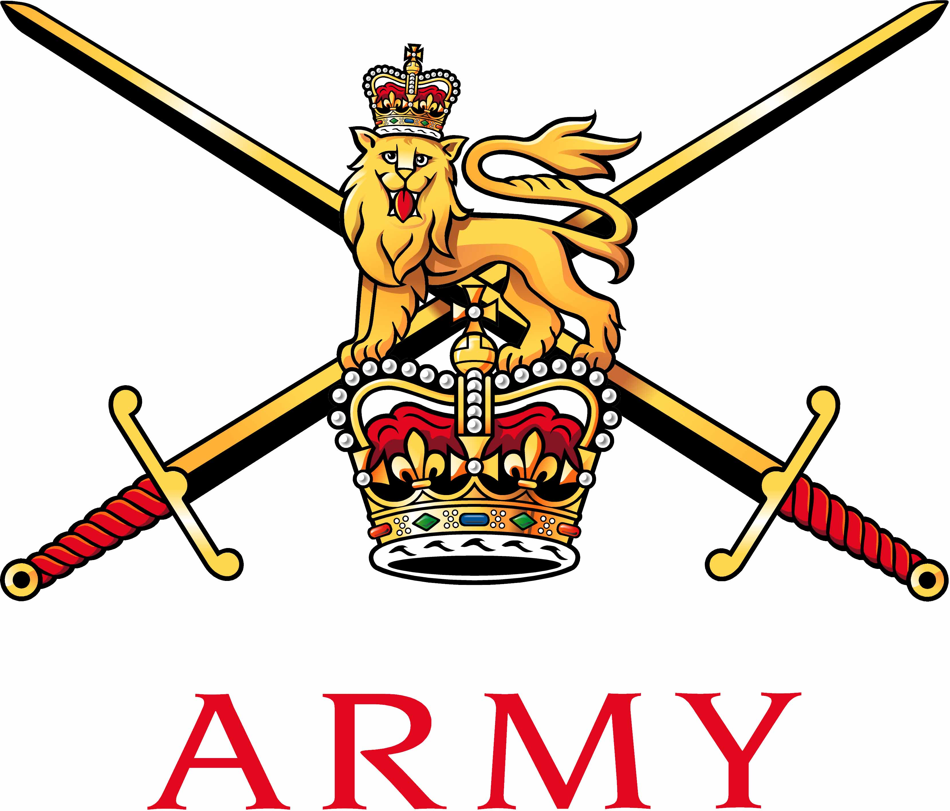 | Secretary Army Boxing Association  Army Sport Control Board  MacKenzie Building, Fox Lines,  ALDERSHOT, Hampshire GU11 2LB  Email: aba@ascb.uk.com  Website: www.britisharmyboxing.com |  | 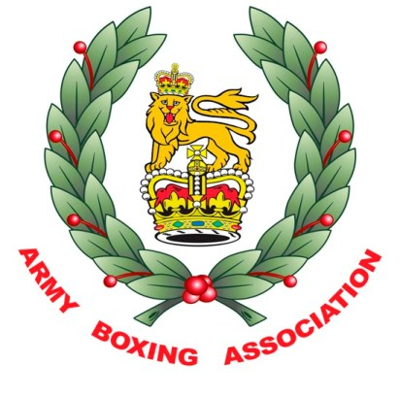
Telephone: 01252 787089 Fax: 01252 787094
Military: 94222 7089 Military: 94222 7094
See Distribution |  | Reference: 20180905_ARMYBA_AGM_SEC_U  Date: 05 Sept 2018

RECORD OF DECISIONS FROM THE ARMY BA AGM HELD AT ARMY SCHOOL OF PHYSICAL TRAINING ALDERSHOT 28th AUGUST 2018

Present | Brig S Hamilton OBE | Chairman | SH
 | Mr N Pearce | Secretary | NP
 | Brig C Barry OBE | Vice Chairman | CB
 | Maj Cugudda | Comms and Media | LC
 | Capt L Harkin | Chairman South | LH
 | Capt Kirkham-Brown | Chairman North | KB
 | SSgt Turner | Secretary South | ST
 | Sgt Allen | Team Coach | JA
 | Mr Ben Stewart | Team Technical Lead | BS
 | Mrs Faye Walters | Army Boxing Admin Officer | FW
Apologies | Dr Walker | Senior Medical Officer | RW
 | Capt Roberts | Officials Appointments Officer | CR
 | Maj Cugudda | Team Manager | DC
 | Maj A Buff | Chairman Midlands | AB
 | WO2 Mann | Secretary North | SM
Item 1 – Introduction and welcome  - Chairman welcomed the members.  - The Chairman commented on the success of the both the Elite and Development Boxing squads and thanked everyone involved in helping to deliver this success.  - The chairman expressed his concern of regeneration of officials, coaches and boxers and would like all to have a think of how this will be done in future.  Item 2 – Previous minutes and matters arising  - The previous minutes were accepted as a true record of the meeting.  Item 3 – Statement of accounts  - Audit. The Army BA is audited as part of the ASCB Central Bank.  - Accounts. The Army BA account 1514 and full audited account was provided to the committee.  - Forecast of expenditure. A forecast for Army BA is required to ensure that funds are available to support the Army Boxing Strategy.  - Overseas Visits – There is a lack of locations within GB to compete in, therefore more visits overseas are needed for the Elite team to be able to compete at a higher standard. SH suggests that a contingency plan is devised to include the stoppage of Overseas visits. A plan of desired locations is also to be prepared so that funding can be looked at more closely.  - Sponsorship.  a - A letter of thanks to be sent to each sponsor to thank them for their financial support to Army BA.  - Techmodal continue as the Army Team shirt sponsor at £10000.  - Babcock continue to sponsor the Army Champs and Army Individuals at £13000  - Selex ES Team Sponsors - £7500  - DB Santasalo Team Sponsors - £3000  - Atkins - £3000  - FBT Boxing kit sponsorship – Clothing and strips.  b – NP explained the change in Sponsorship from Team Army to Mongoose, Army BA could lose some funding by this change, however the DACSB has pledged to match any losses if needed. It was decided that the Army BA should still have a plan in place for three scenarios as protection - 10%, 15% and 20% loss. A small meeting should then take place to discuss this.  Item 4 – Appointments.  - The Army BA new appointments;  - Ben Stewart – Army Performance Team Manager and Technical Lead  - Faye Walters – Registrations and Admin Officer  - Maj Lydia Cugudda – Media and Comms  - Ssgt Stephen Turner – Secretary South  - Ssgt Gordon Bruce – Secretary Midlands  - The Performance Team (Michael, Emily, Rachel and Luke)  - CR will be handing over his appointment – An expression of interest is to be distributed whereby an application form/CV will be required to be put forward and the Executive Committee will then conduct the selection process.  - A discussion took place regarding promotions which will then affect the committee appointments. It was decided that Army BA should consider more than one Vice Chairman with the possibility of one being a serving CO.  Item 5 – Fixtures and Invitations  - A detailed list of fixtures is attached (these include dates for the Inter Services, major events and who is to represent the Army BA) as follows;  - IS Dev Champs – 18 & 20 Sept – Brize Norton -VC  - IS Elite Champs - 19 & 21 March – Portsmouth – President, Chairman, VC  - Army Team Final Aldershot – 09 May (dates of rounds are provided on forecast) - President, VC.  - Army Individual Champs June 2 – 6 June 2019 - President, Chairman, VC  Item 6 – Reports.  - NP summed up the season and provided a report of the previous season;  Army BA  - Army Boxing registered in the 2017/18 season  - Boxers - 1862  - Officials - 167  - Coaches – Qualified – 373 Registered - 446  - Teams Affiliated – 63  - Events licensed – 61  - NP expressed concern with the drop in registrations but explained that this is the affect of the Army becoming smaller. ST explained that RAPCT are automatically trained as J/TK. It was decided that a reminder to register was to be distributed out.  Results  Inter Service Champions 2017  Army Inter Unit Development A Team Championships –  Winners – 13 Air Support Regiment RLC  Finalists – 3rd Battalion the Parachute Regiment  The Army Boxing Association had an extremely successful season;  Individual honours  Cpl Wroe – Army and UKAF Sportswoman of the Year 2016  LCpl Ngwenya GB Elite Title – Winner  England Elite Title – Finalist  Southern Area Belt – Winner  Spr Jones GB Elite Title – Winner  England Elite Title – Winner  GB Potential Podium Squad.  LCpl Williams GB Elite Title – Finalist  Wales Elite Title – Winner  England Elite Title – Bronze  Cpl Wroe – England Elite Title – Winner  GB Elite Title – Finalist  England Title Belt – Holder  LCpl Morrison GB Elite Title – Bronze  Wales Elite Title - Winner  Gnr Fillingham – England Title Belt – Winner  LCpl Khan – England Title Belt – Winner  LCpl Nihell – England Title Belt – Winner  Haringey Box Cup – Winner  Cpl Burton - Scotland Elite Title - Finalist  LCpl Reid - Scotland Elite Title – W/O win  Fus Eng - Scotland Elite Title - Bronze  Cpl A Nihell – Haringey Box Cup - Winner  International appearances  Cpl Burton Scotland  Cpl Wroe England  LCpl Marvin Phillipines  LCpl Morrison Wales  LCpl Nihell England  LCpl Reid Scotland  LCpl Williams Wales  Fus Eng Scotland  Gnr Fillingham England  Spr Jones GB  Team Honours  Inter Service Champions 2017  Haringey Box Cup Runners Up 2017  - Reports from each region and from the Team and Officials were also provided and gave a comprehensive look back at a very successful season in all areas for Army Boxing.  a – North regional secretary highlighted issue with sudden influx of boxers requiring medicals and the stress it puts on the MO’s. NP will highlight this in the Army BA conference and stress the need for units to plan ahead.  b – South Regional Secretary emphasised that units are struggling with space to train as buildings are being repossessed. It was suggested that units should try and share their resources to overcome this issue.  Item 7 – England Boxing & AIBA Update  - NP gave an update on AIBA who have a new interim president, AIBA have some issues that should be tracked but no action is needed by Army BA at present.  - EB update – Rumours they are moving from Sheffield to Manchester, location does not affect Army BA but potentially could affect the relationship we have with staff members.  - EB have proposed weight changes, as they think there should be more weight titles AIBA are yet to decide if they accept them. It was decided to add in 91+kg weight but to be capped at 100 due to safety, by Army BA, however this may have to be adjusted if AIBA decide not to accept them.  Item 8 – Medical Matters  - The committee were informed of the ongoing investigation at 12RA whereby a female boxer was injured during a sparring session. 12RA are, at present conducting a Learning Account of the incident. It was decided that a letter should be drafted to the CO of 12RA outlining the importance of safety and the Army BA protocols.  - It was decided that a reminder about safety protocols during training sessions should be circulated via social networks.  Item 9 - Army Inter Unit Championships.  - The date for the final of the Championships is 05 May 2019, dates for semi-finals and  rounds of the tournament are included on the FOE.  - The competition will remain a straight draw.  - The format for the competition was discussed at length and eventually it was decided that the championship would be contest over 8 weight with all bouts would be boxed over 3 x 2 minute rounds, The weights for the competition and the order they will be boxed is as follows;  9 boxers as 56, 60, 64, 69, 75, 81, 86, 91 and 91+kg  - A match between units will be won if;  - Either units wins 5 or more bouts  - All boxers are to have boxed at least twice but may not have boxed 11 times.  Army Inter Corps and Individual Championships.  - The format for the Army Individual Championships will remain unchanged for 2019 less any rule changes imposed by AIBA or England Boxing.  - The dates for the Championships would be 2 – 6 June 2019.  Inter Service Boxing Championships.  - The date and location for the Inter Services Boxing Championships would be 19 & 21 March in Portsmouth.  Item 12 – AOB.  A - Advertising and Recruiting – A discussion took place reflecting on the way Army BA currently advertises the achievements of its members. LC is currently looking into several ways this can be done. It was decided that the following actions should be taken  - Business cards for BS and JA  - Bios for the boxing team  - Team fact sheet  - Newsletter for units  - Possible Sponsors day in 2019  - Email addresses for Team coaches  - NP advised that 3000 water bottles had been purchased in conjunction with our FBT sponsors and these would be given out as part of the registration process. 30 mugs for the Army BA and UKAFBA had also been purchased for the committees.  B – Swimming - NP advised the committee that as of April 2019 he will no longer be the Army Swimming Union Secretary.  C – GB Performance Team – EB have identified Gunners Artingstall and Willets as potential podium, once they are excepted they will need to be taken off unit PIDS – This was identified as a potential duty of care issue and would need to be investigated further.  D – Registration process – NP explained that NP and FW were working with EB to get the current registration process simplified by allowing Army BA members to access the EB vault to register online as an Army BA member only. This should hopefully be completed by January 2019.  E – Army BA Handbook – NP confirmed that this is now complete and will be released at the Army Boxing Conference. NP to send to SH  F – UKAFBA – NP is the permanent secretary for the UKAFBA, he explained that the Navy do not understand why they must adhere to Army BA rules and therefore suggested that there is a UKAFBA handbook instead of an Army BA handbook, that all three services work to.  Item 12 – Date of the next meeting  30. January 2018 |  |  | NP  BS/NP  BS/JA  SH  NP  CH/NP  SH  CR  NP  NP/SH  NP  NP/LC/SH  NP/LC  LC  LC/JA  LC/JA  LC/JA/BS  LC/NP  FW  NP/SH  NP/FW  NP

N L Pearce
For Chairman

Distribution:

All ARMY BA members

